Wireless Security

Minimize Security Risks in a Wireless LAN

Weight: /1.15% Marks:  /17

Student Name:

Student ID: Date:

# Introduction

In this lab, we focus on the implementation of NON-802.11 technology.

Lab activities in this course will be marked in class. You must bring this document to every lab in the module. All activities must be completed and then marked by the instructor before you move on to the next. To avoid a mark of zero for an activity, contact the instructor immediately if for any reason you cannot complete the activity or if the activity was left unmarked by the instructor.

# Equipment

* Workstation (Kali w/ NON-802.11 technology transceiver)
* NON-802.11 technology
* Topology

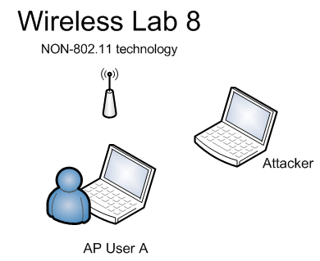

© 2017, Southern Alberta Institute of Technology

# Lab Set Up

Before you begin the lab activities, perform the steps below to set up your computer.

1. Set up a workstation the following parameters:

* Wireless Network Adapter
* Install WiFi Inspector
* Latest version of Wireshark with Winpcap

# Instructor Demo

Instructor will perform an on screen demo of:

* Locating ZigBee devices with signal analysis tools
* Identifying, locating, and assessing an unauthorized Bluetooth device

## Lab Activity 8.1: Verify instructor file location

## Open Zigbee pcap file (zigbee-join-authenticate) (2 points)

## Identify the packet containing the key exchanged: ___________, provide screen shot (2 points)

## What is the type of packet to join-authenticate to Zigbee? _____________________ (2 points)

## Open Zigbee pcap file (zigbee-sample_control4_2012-03-24) (2 points)

## Identify the packet containing the device control: ___________, provide screen shot (2 points)

## Are there vulnerabilities not mentioned above? (2 points) _____________________

## ______________________________________________________________________

_____________________________________________________________________

**Instructor sign-off:** __________________ (5 points)

## 